`
sSQL Questions

1.Write an SQL query that reports all the possible matches of the league. Note that every two teams play two matches with each other, with one team being the home_team once and the other time being the away_team. Return the result table in any order. The query result format is in the following example.
This question was asked in a Microsoft company interview.

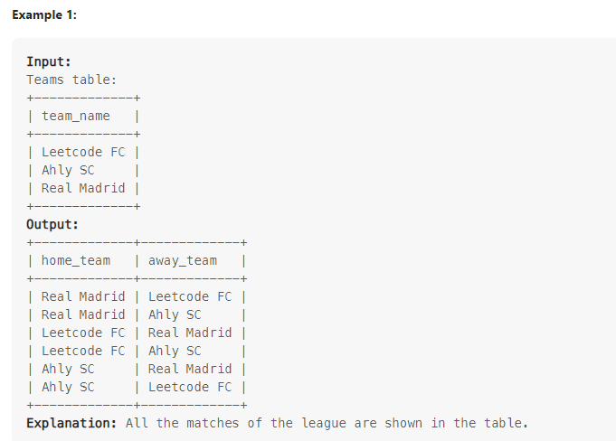

select teams.team_name as home_team,tm.team_name as away_team from teams cross join teams as tm where tm.team_name <> teams.team_name order by teams.team_name desc ;

2. Write an SQL query that reports the spending of each user. Return the resulting table ordered by spending in descending order. In case of a tie, order them by user_id in ascending order. The query result format is in the following example.
This question was asked in an Amazon company interview.
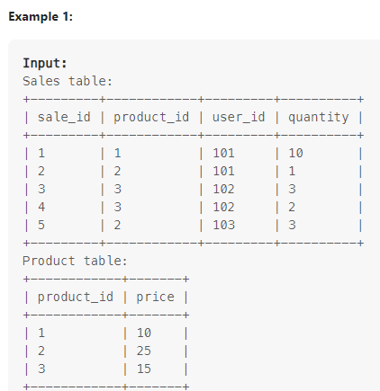
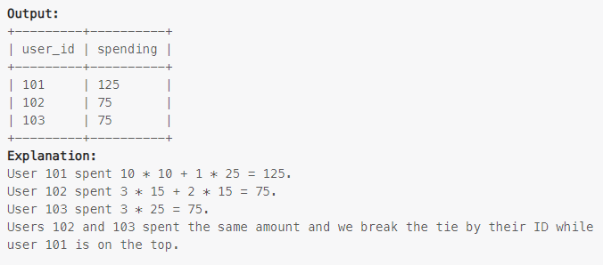
select user_id,sum(price) from sales as s join product as p on s.product_id=p.product_id group by user_id order by sum(price) desc,user_id asc;
3. Write an SQL query to report the number of unique subjects each teacher teaches in the university. Return the result table in any order. The query result format is shown in the following example.
This question was asked in a Capgemini company interview.

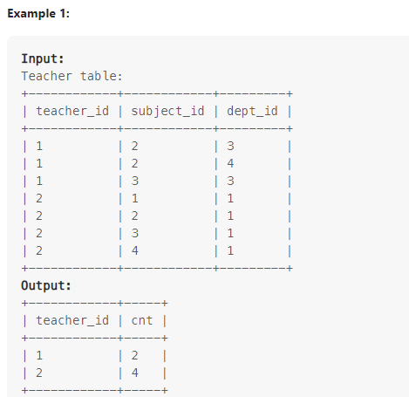
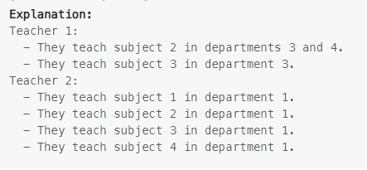

select teacher_id,count(distinct subject_id) as cnt from teacher group by teacher_id ;

4. The Olympic table is sorted according to the following rules: The country with more gold medals comes first. If there is a tie in the gold medals, the country with more silver medals comes first. If there is a tie in the silver medals, the country with more bronze medals comes first. If there is a tie in the bronze medals, the countries with the tie are sorted in ascending order lexicographically. Write an SQL query to sort the Olympic table The query result format is shown in the following example.

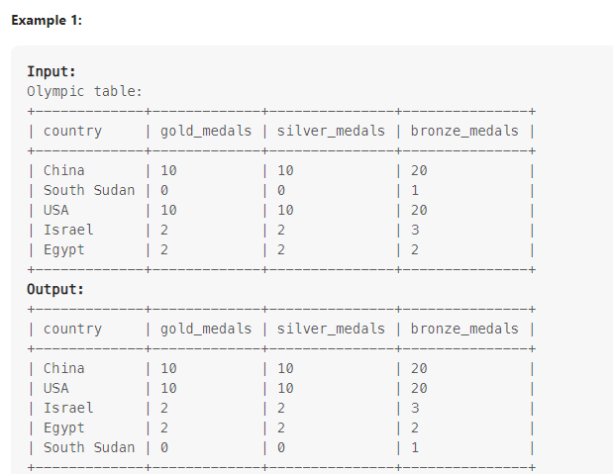
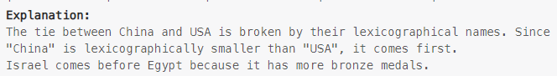

select * from olympic_table order by gold_medals desc,silver_medals desc,bronze_medals desc,country asc;

5. Two elements can form a bond if one of them is 'Metal' and the other is 'Nonmetal'. Write an SQL query to find all the pairs of elements that can form a bond. Return the result table in any order. The query result format is in the following example.

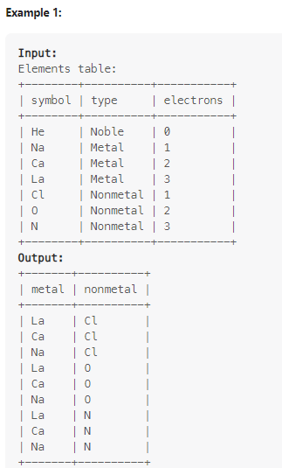
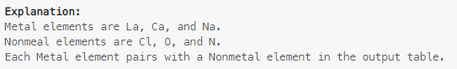

with cte as (select ele.symbol as metals,e.symbol as nonmetals ,row_number() over (partition by ele.electrons order by e.electrons ) as r from elements as ele cross join elements as e where e.type<>ele.type and ele.type<>'Noble' and e.type<>'Noble' and ele.type='Metal' order by r,ele.electrons desc)
select metals, nonmetals from cte;

6. Write an SQL query to report each person's name followed by the first letter of their profession enclosed in parentheses. Return the result table ordered by person_id in descending order. The query result format is shown in the following example.

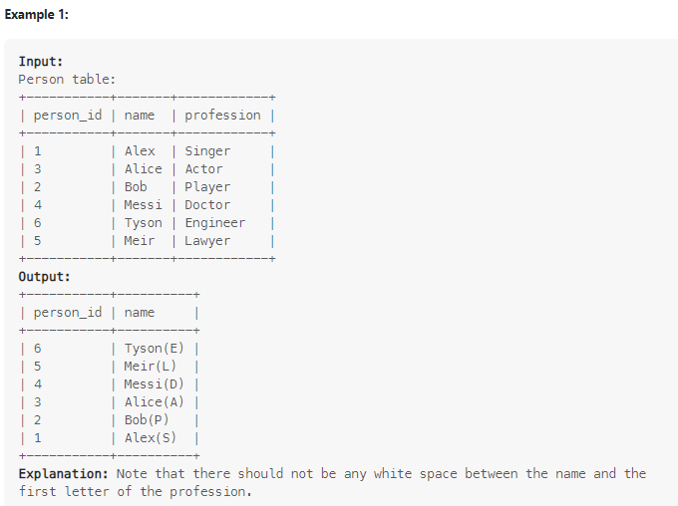

select person_id , concat(name,'(',substr(profession,1,1),')') as name from person order by person_id desc;

7. Write an SQL query to find the last time when each bike was used. Return the result table ordered by the bikes that were most recently used. The query result format is in the following example.

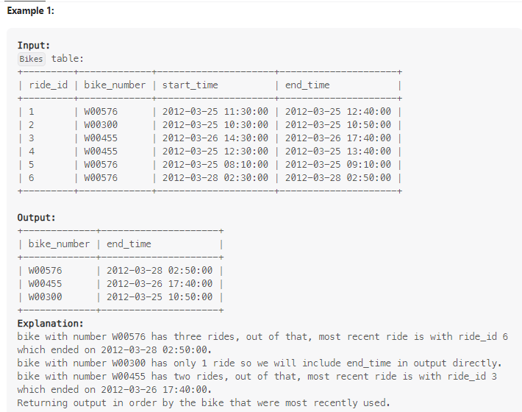

select bike_number, max(end_time) from bikes group by bike_number order by max(end_time) desc;

8. Employees can belong to multiple departments. When the employee joins other departments, they need to decide which department is their primary department. Note that when an employee belongs to only one department, their primary column is 'N'. Write an SQL query to report all the employees with their primary department. For employees who belong to one department, report their only department. Return the result table in any order. The query result format is in the following example.

This question was asked in a Facebook company interview.
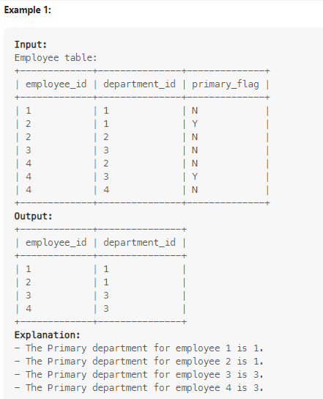
with cte as (select employee_id,department_id,row_number() over (partition by employee_id order by primary_flag desc) as rn from employee)
select employee_id,department_id from cte where rn=1;

9. Write an SQL query to report all the sessions that did not get shown any ads. Return the result table in any order. The query result format is in the following example.
This question was asked in an Amazon company interview.

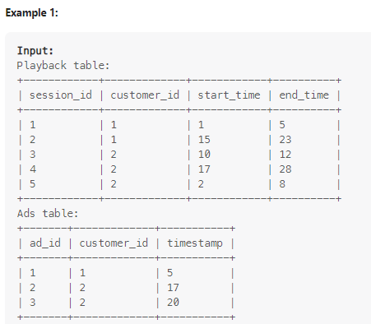
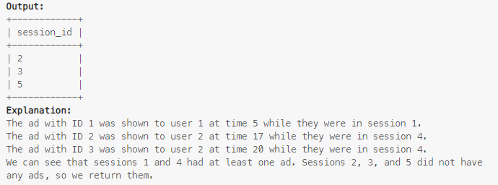
select session_id from ads as ad join playback as p on ad.customer_id=p.customer_id where ad.timestamp not between p.start_time and p.end_time group by session_id;

10. Write an SQL query to convert each date in Days into a string formatted as "day_name, month_name day, year". Return the result table in any order. The query result format is in the following example.
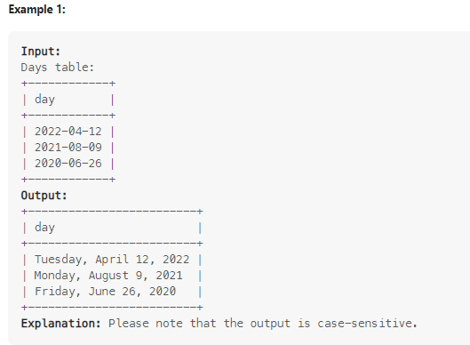

select concat(dayname(day),',',monthname(day),' ',day(day),',',year(day)) as day from days order by year(day) desc;

11. Write an SQL query to calculate the bonus of each employee. The bonus of an employee is 100% of their salary if the ID of the employee is an odd number and the employee name does not start with the character 'M'. The bonus of an employee is 0 otherwise. Return the result table ordered by employee_id. The query result format is in the following example.
This question was asked by an Apple company interview.

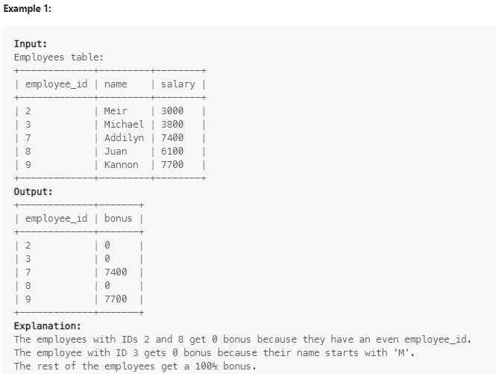

CREATE TABLE Employees (
employee_id INT PRIMARY KEY,
name VARCHAR(50),
salary INT
);
INSERT INTO Employees (employee_id, name, salary) VALUES
(2, 'Meir', 3000),
(3, 'Michael', 3800),
(7, 'Addilyn', 7400),
(8, 'Juan', 6100),
(9, 'Kannon', 7700);

select employee_id,(case when employee_id %2 <>0 and name not like 'M%' then salary else 0 end) as bonus from employees order by employee_id ;

12. Write an SQL query to report the IDs of the low-quality problems. A LeetCode problem is low-quality if the like percentage of the problem (number of likes divided by the total number of votes) is strictly less than 60%. Return the result table ordered by problem_id in ascending order. The query result format is in the following example.

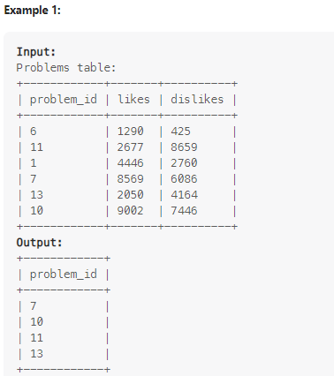

select problem_id from problems where (likes/(likes+dislikes))<0.6;

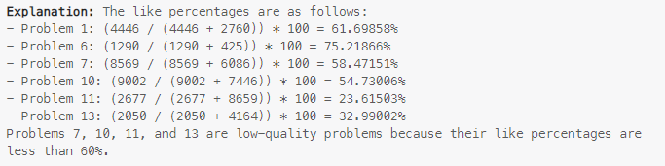

13. There is a competition between New York University and California University. The competition is held between the same number of students from both universities. The university that has more excellent students wins the competition. If the two universities have the same number of excellent students, the competition ends in a draw. An excellent student is a student that scored 90% or more in the exam. Write an SQL query to report: "New York University" if New York University wins the competition. "California University" if California University wins the competition. "No Winner" if the competition ends in a draw. The query result format is in the following example.

This question was asked in a Walmart Global Tech company.
with cte as (select count(*) as cnt from newyork where score >=90)
select (case when count(*)>(select cnt from cte)then 'California university' else 'New york university' end) as Winner from california where score>=90;
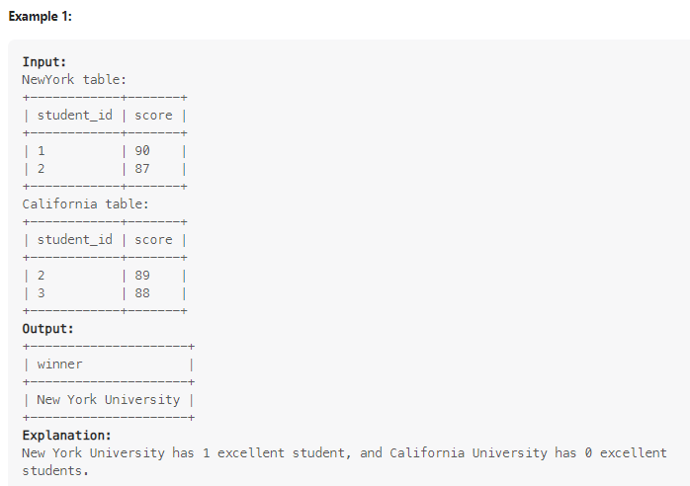

14. Write an SQL query to show the unique ID of each user, If a user does not have a unique ID replace just show null. Return the result table in any order. The query result format is in the following example.

This question was asked in a Point72 company interview.

select (case when id not in (select id from employeeuni) then null else (select unique_id from employeeuni where id=employees.id) end ) as unique_id,name from employees ;
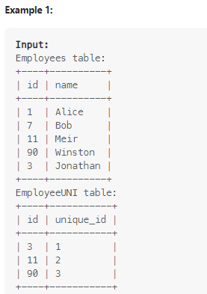
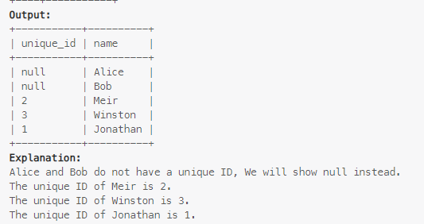

15. Write an SQL query to report the patient_id, patient_name and conditions of the patients who have Type I Diabetes. Type I Diabetes always starts with DIAB1 prefix. Return the result table in any order. The query result format is in the following example.

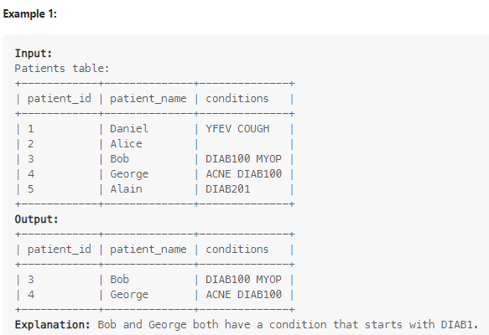

select * from patients where conditions like '%DIAB1%';

16. Write an SQL query to find the IDs of the invalid tweets. The tweet is invalid if the number of characters used in the content of the tweet is strictly greater than 15. Return the result table in any order. The query result format is in the following example.
This question was asked in a Twitter company interview.
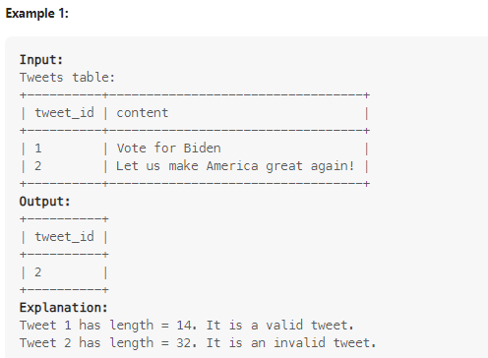

select tweet_id from tweets where char_length(content)>15;

17. You want to know how long a user visits your application. You decided to create bins of "[0-5>", "[5-10>", "[10-15>", and "15 minutes or more" and count the number of sessions on it. Write an SQL query to report the (bin, total). Return the result table in any order. The query result format is in the following example.
This question was asked in a Twitch company interview.

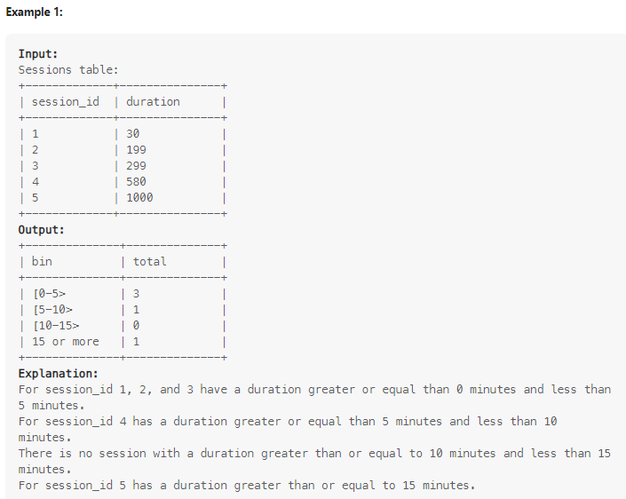

create table t (bin varchar(45));
insert into t values ('[0-5>'),('[5-10>') ,('[10-15>'),('15 or more');

with cte as (select case when duration/60 >0 and duration/60 <5 then '[0-5>' when duration/60>=5 and duration/60<10 then '[5-10>' when duration/60>=10 and duration/60<15 then '[10-15>' else '15 or more' end as bin ,count(*) as total from sessions group by bin)

select bin,(case when bin not in (select bin from cte) then 0 else (select total from cte where bin=t.bin) end) as Total from t ;

18. Write an SQL query to report the distinct titles of the kid-friendly movies streamed in June 2020. Return the result table in any order. The query result format is in the following example.
This question was asked in an Amazon company interview.
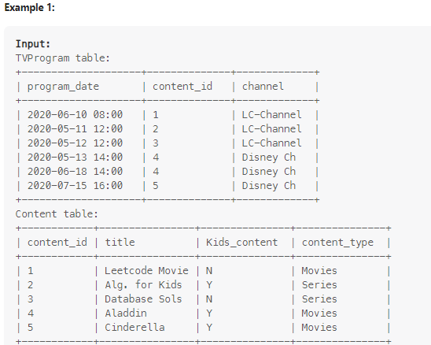
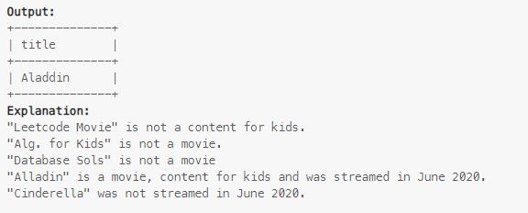

create view v as (select content_id from tvprogram where monthname(program_date)='june' and year(program_date)='2020');
select title from content where content_id in (select content_id from v )and content_type='movies' and kids_content='y';

19. Since table Sales was filled manually in the year 2000, product_name may contain leading and/or trailing white spaces, also they are case-insensitive. Write an SQL query to report product_name in lowercase without leading or trailing white spaces. sale_date in the format ('YYYY-MM'). total the number of times the product was sold in this month. Return the result table ordered by product_name in ascending order. In case of a tie, order it by sale_date in ascending order. The query result format is in the following example.

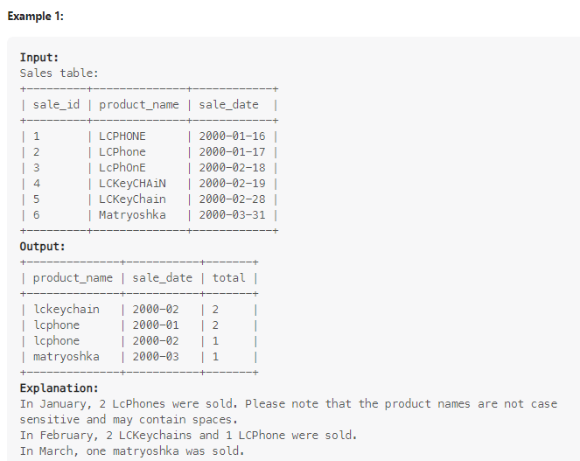

SELECT
LOWER(product_name) AS product,
DATE_FORMAT(sale_date, '%Y-%m') AS year_month,
COUNT(*) AS total
FROM sales
GROUP BY LOWER(product_name), DATE_FORMAT(sale_date, '%Y-%m')
ORDER BY product, year_month;

20. Write an SQL query to find the type of weather in each country for November 2019. The type of weather is: Cold if the average weather_state is less than or equal 15, Hot if the average weather_state is greater than or equal to 25, and Warm otherwise. Return result table in any order. The query result format is in the following example.
This question was asked in a Point72 company interview.

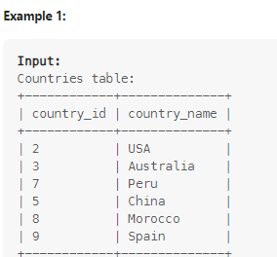
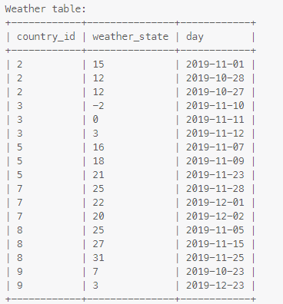

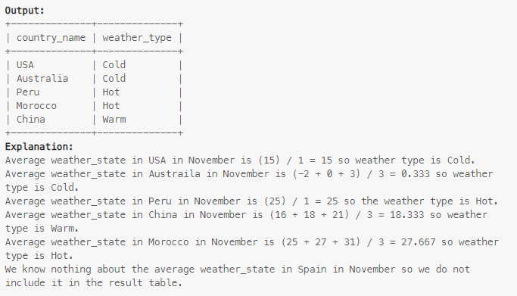
select (select country_name from countries where country_id=weather.country_id) as country_name, (case when avg(weather_state)<=15 then 'Cold' when avg(weather_state)>=25 then 'Hot' else 'Warm' end ) as weather_type from weather where (month(day)=11 and year(day)=2019 )
group by country_id order by weather_type;

21. Write an SQL query to report the IDs of all the products that were ordered three or more times in two consecutive years. Return the result table in any order. The query result format is shown in the following example.
This question was asked in an Amazon company interview.

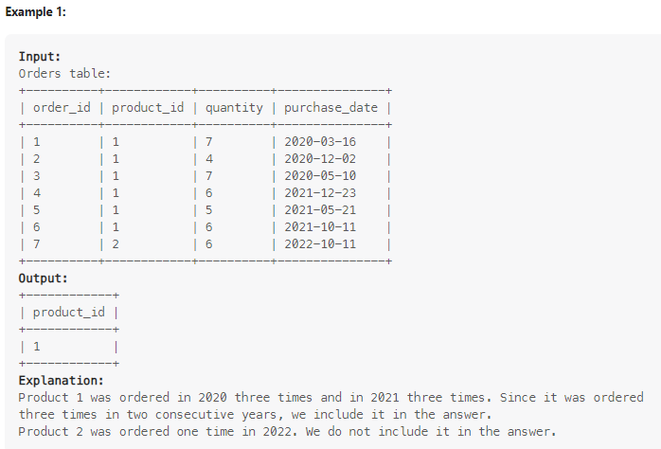
with cte as (select product_id,year(purchase_date) as yr from orders group by product_id,year(purchase_date) having count(order_id)>=3)
,cte1 as (select (case when (lead(yr,1,0) over (order by yr))-yr=1 then product_id end) as product_id from cte)
select * from cte1 where product_id is not null ;

22. Write an SQL query to report: the number of the tasks that were submitted during the weekend (Saturday, Sunday) as weekend_cnt, and the number of the tasks that were submitted during the working days as working_cnt. Return the result table in any order. The query result format is shown in the following example.

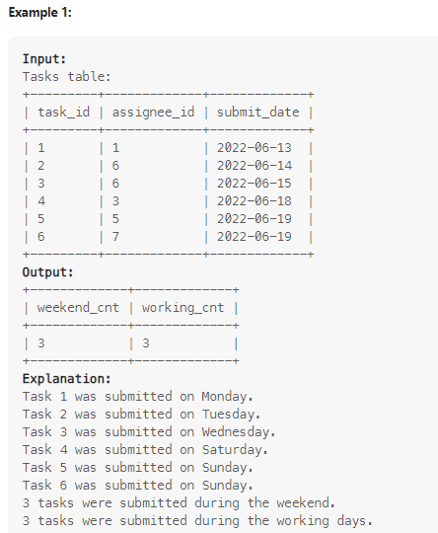
create table days(name varchar(266) );
insert into days values ('monday'),('tuesday'),('wednesday'),('thursday'),('friday'),('saturday'),('sunday');
with cte as (select case when dayname(submit_date)<> 'saturday' and dayname(submit_date)<> 'sunday' then 'weekday' end as t ,case when dayname(submit_date)= 'saturday' or dayname(submit_date)= 'sunday' then 'weekday' end as t1 from tasks )
select count(t) as working_cnt,count(t1) as weekend_cnt from cte ;

23. Write an SQL query to rearrange the Genders table such that the rows alternate between 'female', 'other', and 'male' in order. The table should be rearranged such that the IDs of each gender are sorted in ascending order. Return the result table in the mentioned order. The query result format is shown in the following example.

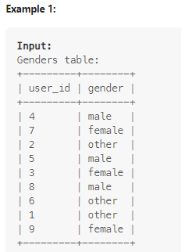

with cte as (select * ,row_number() over (partition by gender order by user_id) as rn from genders order by rn ,case when gender='female' then 1 when gender='other' then 2 else 3 end)
select user_id,gender from cte;
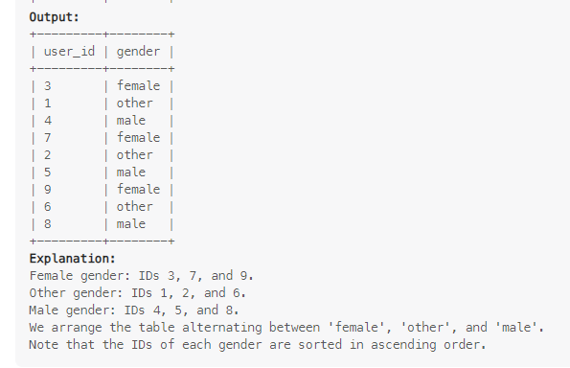

24. Write an SQL query to report the day that has the maximum recorded degree in each city. If the maximum degree was recorded for the same city multiple times, return the earliest day among them. Return the result table ordered by city_id in ascending order. The query result format is shown in the following example.

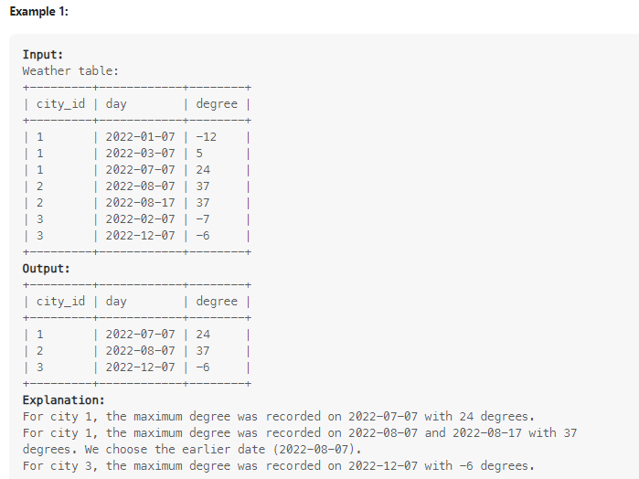

with cte as (select * ,row_number() over (partition by city_id order by degree desc,day asc ) as rn from weather)
select city_id,day,degree from cte where rn=1;

25. Write an SQL query to replace the null values of drink with the name of the drink of the previous row that is not null. It is guaranteed that the drink of the first row of the table is not null. Return the result table in the same order as the input. The query result format is shown in the following example.
This question was asked in a Deloitte company interview.

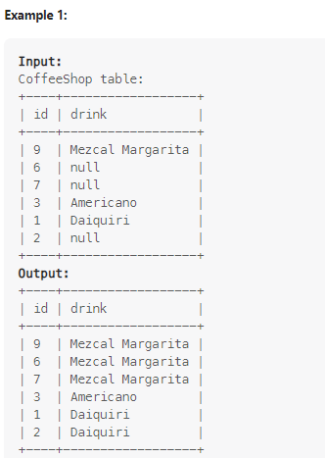
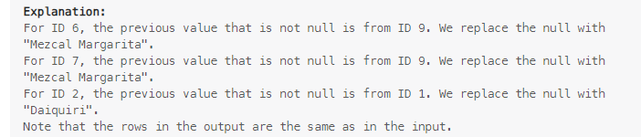
WITH
S AS (
SELECT *, row_number() OVER () AS rk
FROM CoffeeShop
),
T AS (
SELECT
*,
sum(
CASE
WHEN drink IS NULL THEN 0
ELSE 1
END
) OVER (ORDER BY rk) AS gid
FROM S
)
SELECT
id,
max(drink) OVER (
PARTITION BY gid
ORDER BY rk
) AS drink
FROM T;

26. In a company, each employee must work a certain number of hours every month. Employees work in sessions. The number of hours an employee worked can be calculated from the sum of the number of minutes the employee worked in all of their sessions. The number of minutes in each session is rounded up. For example, if the employee worked for 51 minutes and 2 seconds in a session, we consider it 52 minutes. Write an SQL query to report the IDs of the employees that will be deducted. In other words, report the IDs of the employees that did not work the needed hours. Return the result table in any order. The query result format is in the following example.
This question was asked in an Amazon company interview.

with cte as (select *,timestampdiff(hour,in_time,out_time) as dif from logs)
,cte1 as (select employee_id from cte group by employee_id having (case when employee_id=1 then sum(dif)<20 when employee_id=2 then sum(dif)<12 when employee_id=3 then sum(dif )<2 end ) )
select employee_id from cte1 union all select employee_id from employees where employee_id not in (select employee_id from cte);
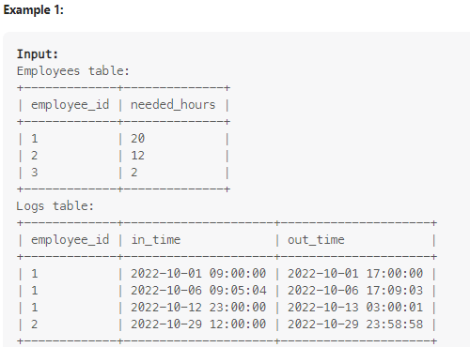
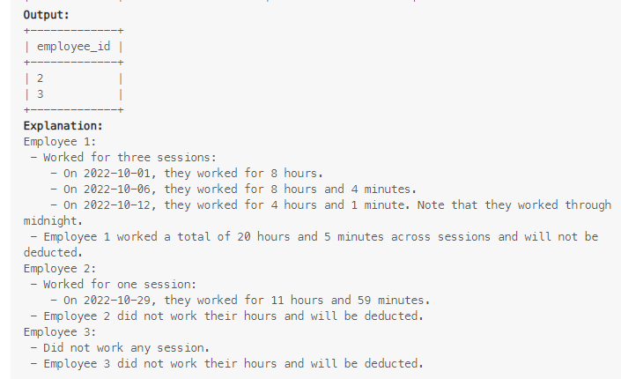
27. If the customer's preferred delivery date is the same as the order date, then the order is called immediate, otherwise, it is scheduled. Write an SQL query to find the percentage of immediate orders on each unique order_date, rounded to 2 decimal places. Return the result table ordered by order_date in ascending order. The query result format is in the following example.

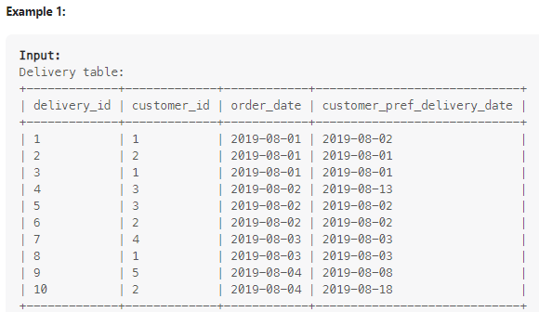
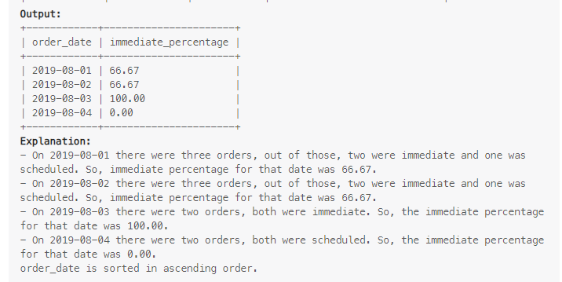

create view v as (select order_date as ord,count(* ) as cnt from delivery group by order_date);
create view v1 as (select order_date,round( (count(*)/(select cnt from v where ord=delivery.order_date))*100,2) as immeediate_percentage from delivery where order_date=customer_pref_delivery_date group by order_date);
select distinct(order_date),0 as cnt from delivery where order_date not in (select order_date from v1) union select order_date,immeediate_percentage from v1 order by order_date;

28. Write an SQL query that'll identify active users. An active user is a user that has made a second purchase within 7 days of any other of their purchases. For example, if the ending date is May 31, 2023. So any date between May 31, 2023, and June 7, 2023 (inclusive) would be considered "within 7 days" of May 31, 2023. Return a list of user_id which denotes the list of active users in any order. The query result format is in the following example.
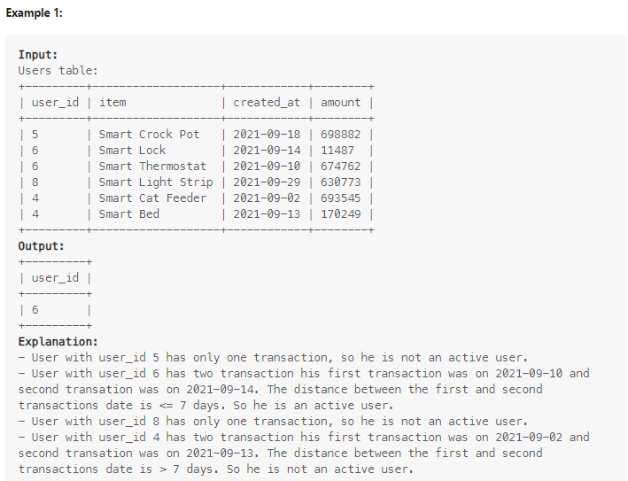
with cte as (select user_id from users group by user_id having count(distinct item)>1)
, cte1 as (select datediff( lead(created_at,1,created_at) over (partition by user_id order by created_at ),created_at) as df,user_id from users where user_id in (select user_id from cte) )
select user_id from cte1 where df>0 and df<7 group by user_id;

29. Write an SQL query to report the number of grand slam tournaments won by each player. Do not include the players who did not win any tournament. Return the result table in any order. The query result format is in the following example.

This question was asked in an Amazon company interview.

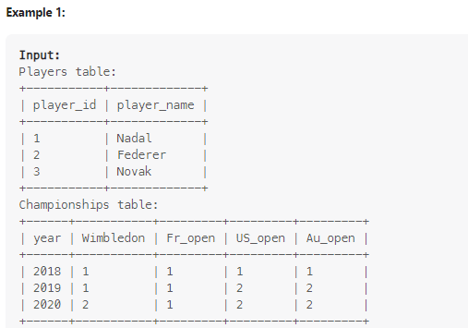
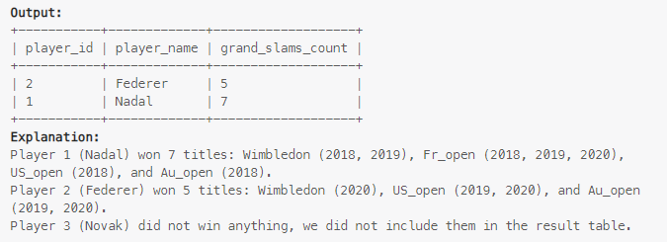

with cte as (select wimbledon as us,count(*) as cnt from championships as ch group by wimbledon),
cte1 as (select fr_open as us1,count(*) as cnt1 from championships as ch group by fr_open),
cte2 as (select us_open as us2,count(*) as cnt2 from championships as ch group by us_open),
cte3 as (select Au_open as us3,count(*) as cnt3 from championships as ch group by Au_open),
ct as (select * from cte union all select * from cte1 union all select * from cte2 union all select * from cte3)
select us as player_id,(select player_name from players where player_id =ct.us) as player_name,sum(cnt) as grand_slams_count from ct group by us;

30. Write an SQL query to report the name and the mail of all interview candidates. A user is an interview candidate if at least one of these two conditions is true: The user won any medal in three or more consecutive contests. The user won the gold medal in three or more different contests (not necessarily consecutive). Return the result table in any order. The query result format is in the following example.
This question was asked in an Amazon company interview.
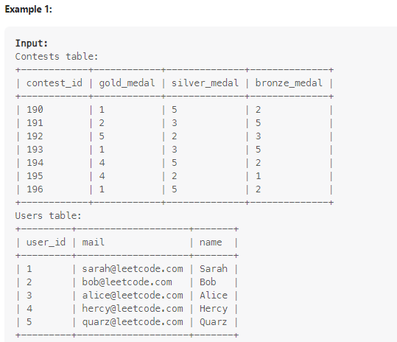
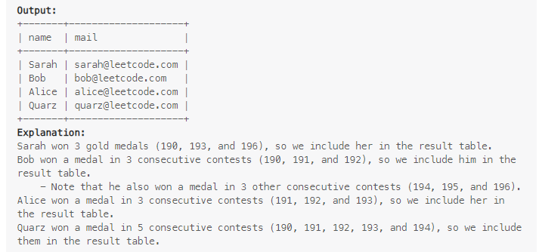

with cte as (select (case when gold_medal=1 or silver_medal=1 or bronze_medal =1 then contest_id end) as u1,(case when gold_medal=2 or silver_medal=2 or bronze_medal =2 then contest_id end) as u2,
(case when gold_medal=3 or silver_medal=3 or bronze_medal =3 then contest_id end) as u3,(case when gold_medal=4 or silver_medal=4 or bronze_medal =4 then contest_id end) as u4,
(case when gold_medal=5 or silver_medal=5 or bronze_medal =5 then contest_id end) as u5
from contests),
c5 as (select lead(u5,1,u5) over (order by u5)-u5 as dif5 ,u5 from cte group by u5) ,
c4 as (select lead(u4,1,u4) over (order by u4)-u4 as dif4,u4 from cte group by u4) ,
c3 as (select lead(u3,1,u3) over (order by u3)-u3 as dif3,u3 from cte group by u3) ,
c2 as (select lead(u2,1,u2) over (order by u2)-u2 as dif2 ,u2 from cte group by u2) ,
c1 as (select lead(u1,1,u1) over (order by u1)-u1 as dif1,u1 from cte group by u1 ),
ct6 as (
SELECT COUNT(dif1) AS cnt, 1 AS user_id FROM c1 WHERE dif1 IN (0,1)
UNION ALL
SELECT COUNT(dif2) AS cnt, 2 AS user_id FROM c2 WHERE dif2 IN (0,1)
UNION ALL
SELECT COUNT(dif3) AS cnt, 3 AS user_id FROM c3 WHERE dif3 IN (0,1)
UNION ALL
SELECT COUNT(dif4) AS cnt, 4 AS user_id FROM c4 WHERE dif4 IN (0,1)
UNION ALL
SELECT COUNT(dif5) AS cnt, 5 AS user_id FROM c5 WHERE dif5 IN (0,1)
)
select name,mail from users where user_id in (select user_id from ct6 where cnt>=3) or user_id in (select gold_medal from contests group by gold_medal having count(*)>=3);

31. A bank account is suspicious if the total income exceeds the max_income for this account for two or more consecutive months. The total income of an account in some month is the sum of all its deposits in that month (i.e., transactions of the type 'Creditor'). Write an SQL query to report the IDs of all suspicious bank accounts. Return the result table in any order. The query result format is in the following example.

This question was asked in a JPMorgan company interview.

with cte as (select account_id,date_format(day,'%Y-%m') as ti ,sum(amount) as amt from transactions as t where type='Creditor' group by account_id,date_format(day,'%Y-%m')
having sum(amount)>(select max_income from accounts where account_id=t.account_id) order by account_id,ti )
,cte1 as (select *,concat(ti,'-01') as tii from cte)
,cte2 as (select *, timestampdiff(month,tii,lead(tii,1,tii) over (partition by account_id order by tii)) as diff from cte1 order by account_id)
select account_id from cte2 where diff=0 or diff=1 group by account_id having count(diff)-1<=sum(diff)<count(diff);
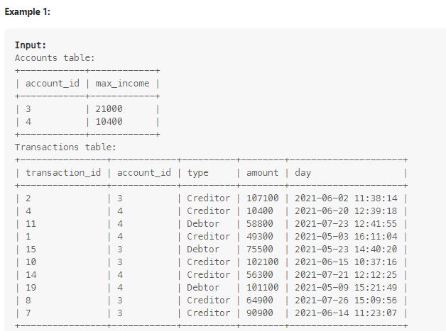
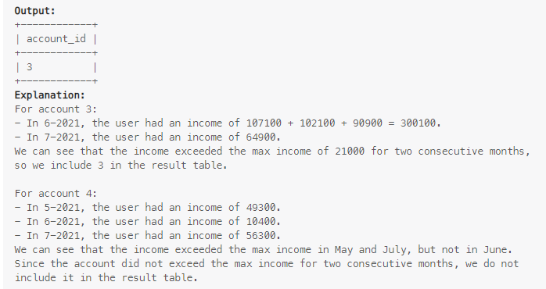

32. Write an SQL query to report the number of bank accounts of each salary category. The salary categories are: "Low Salary": All the salaries strictly less than $20000. "Average Salary": All the salaries in the inclusive range [$20000, $50000]. "High Salary": All the salaries strictly greater than $50000. The result table must contain all three categories. If there are no accounts in a category, then report 0. Return the result table in any order. The query result format is in the following example.

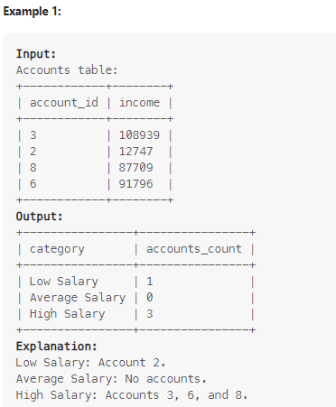

create table c (cat varchar(29));
insert into c values('Low Salary'),('High Salary'),('Average Salary');
with cte as (select (case when income<20000 then 'Low Salary' when income>=20000 and income<=50000 then 'Average Salary' else 'High Salary' end) as category from accounts)
, cte1 as (select category,count(*) as accounts_count from cte group by category)
select cat as category,0 as accounts_count from c where cat not in (select category from cte1) union all
select * from cte1 order by (case when category='Low Salary' then 1 when category='Average Salary' then 2 else 3 end);

33. The confirmation rate of a user is the number of 'confirmed' messages divided by the total number of requested confirmation messages. The confirmation rate of a user that did not request any confirmation messages is 0. Round the confirmation rate to two decimal places. Write an SQL query to find the confirmation rate of each user. Return the result table in any order. The query result format is in the following example.

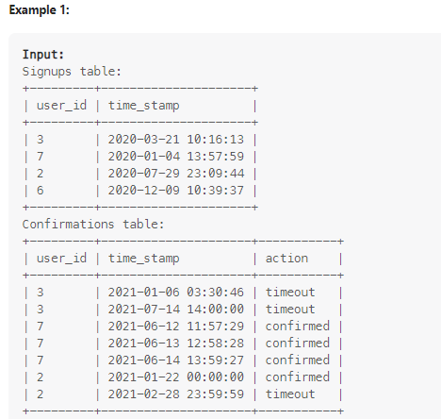

34. A friendship between a pair of friends x and y is strong if x and y have at least three common friends. Write an SQL query to find all the strong friendships. Note that the result table should not contain duplicates with user1_id < user2_id. Return the result table in any order. The query result format is in the following example.

This question was asked in a Facebook company interview.

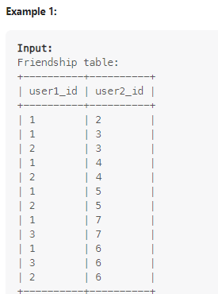
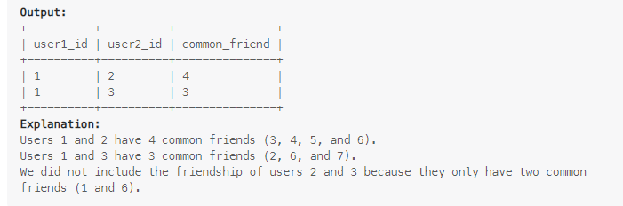
with cte as (
select fr.user1_id,fr.user2_id,f.user2_id as f1_ from friendship as fr join friendship as f on fr.user2_id=f.user1_id union all
select fr.user1_id,fr.user2_id,f.user1_id as f1_ from friendship as fr join friendship as f on fr.user2_id=f.user2_id order by user1_id,user2_id),
cte1 as(
select fr.user1_id,fr.user2_id,f.user2_id as f1_ from friendship as fr join friendship as f on fr.user1_id=f.user1_id union all
select fr.user1_id,fr.user2_id,f.user1_id as f1_ from friendship as fr join friendship as f on fr.user1_id=f.user2_id order by user1_id,user2_id)
,cte2 as (select * from cte union all (select * from cte1))
select user1_id,user2_id,count(*)-count(distinct(f1_)) as common_friend from cte2 where f1_ <> user1_id and f1_ <> user2_id group by user1_id,user2_id having count(*)-count(distinct(f1_))>=3 ;

35. Write an SQL query to report the number of experiments done on each of the three platforms for each of the three given experiments. Notice that all the pairs of (platform, experiment) should be included in the output including the pairs with zero experiments. Return the result table in any order. The query result format is in the following example.
This question was asked in a Strava company interview.

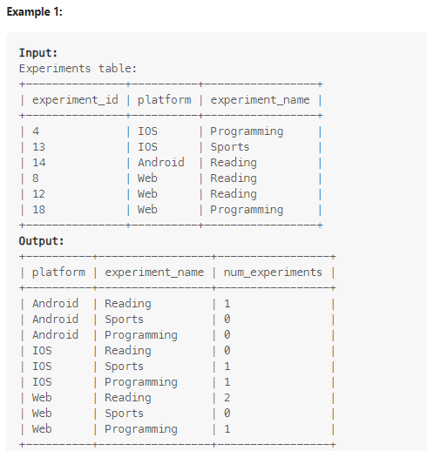
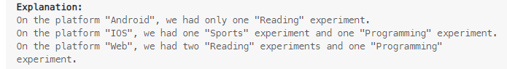

with c1 as (select distinct(platform) as plt,(experiment_name) as ex,count(*) as num_experiments from experiments as e group by platform,experiment_name),
cte as (select distinct platform from experiments),
c as (select distinct experiment_name from experiments )
select *,(case when platform in (select plt from c1 where ex=c.experiment_name) then (select num_experiments from c1 where plt=cte.platform and ex=c.experiment_name) else 0 end) as Num_experiments from cte cross join c order by cte.platform,(case when experiment_name='reading'
then 1 when experiment_name='sports'then 2 else 3 end);

36. Write an SQL query to report the balance of each user after each transaction. You may assume that the balance of each account before any transaction is 0 and that the balance will never be below 0 at any moment. Return the result table in ascending order by account_id, then by day in case of a tie. The query result format is in the following example.

with cte as (select * ,(case when type='deposit' then +(amount) else -(amount) end ) as ch from transactions as tr)
select account_id,day,sum(ch) over (partition by account_id order by day) as balance from cte order by account_id,day;
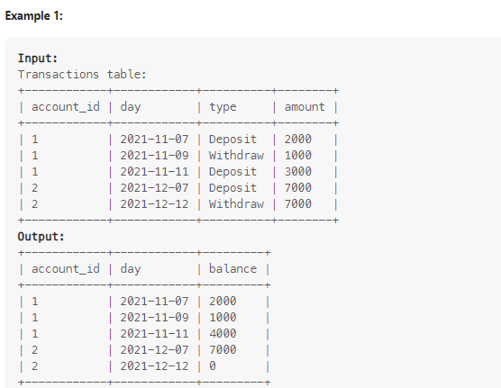
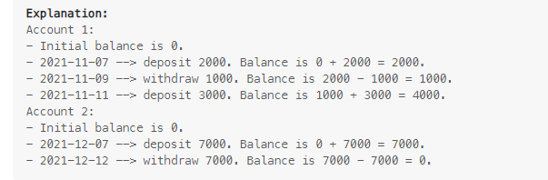

37. Write an SQL query to report the ID of the airport with the most traffic. The airport with the most traffic is the airport that has the largest total number of flights that either departed from or arrived at the airport. If there is more than one airport with the most traffic, report them all. Return the result table in any order. The query result format is in the following example.

with ct as (select departure_airport as 1_,sum(flights_count) as 2_ from flights group by departure_airport),
cte as (select arrival_airport as 1_,sum(flights_count) as 2_ from flights group by arrival_airport),
c as (select * from ct union all select * from cte)
,c1 as (select 1_,sum(2_) as s from c group by 1_ limit 1)
select 1_ from c group by 1_ having sum(2_) in (select s from c1);

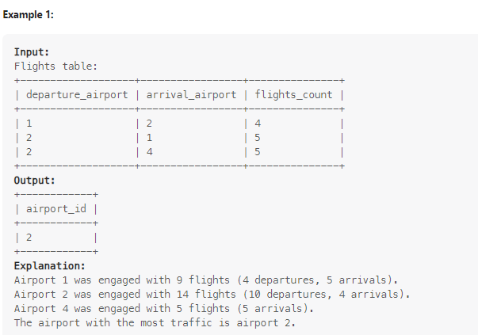

38. Buses and passengers arrive at the LeetCode station. If a bus arrives at the station at time tbus and a passenger arrived at time tpassenger where tpassenger <= tbus and the passenger did not catch any bus, the passenger will use that bus. Write an SQL query to report the number of users that used each bus. Return the result table ordered by bus_id in ascending order. The query result format is in the following example.

with cte as (select passenger_id,min(bus_id) as b from Passengers cross join buses where Passengers.arrival_time<=buses.arrival_time group by passenger_id),
ct1 as (select bus_id, 0 as pasengers_count from buses where bus_id not in (select b from cte))
select * from ct1 union all (select b as bus_id,count(passenger_id) as pasengers_count from cte group by b) order by bus_id;

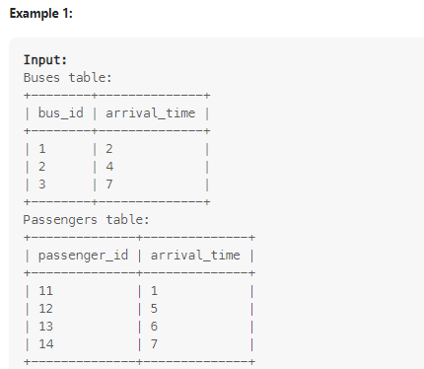

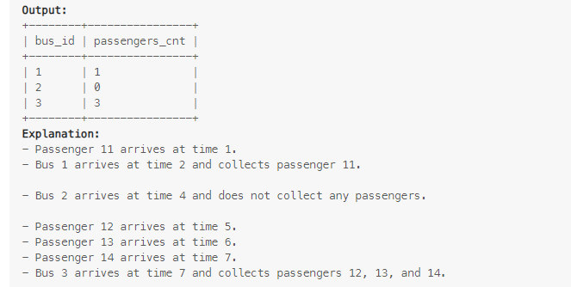

39. Write an SQL query to independently: order first_col in ascending order and order second_col in descending order. The query result format is in the following example.
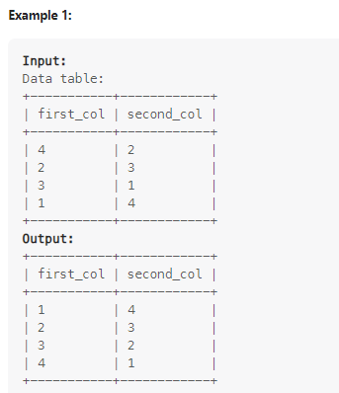

with cte as (select first_col,row_number() over (order by first_col) as r from data ),

c1 as (select second_col,row_number() over (order by second_col desc) as r from data )

select first_col,second_col from cte join c1 on cte.r=c1.r ;

40. Write an SQL query to evaluate the boolean expressions in Expressions table. Return the result table in any order. The query result format is in the following example.
This question was asked in a Point72 company interview.
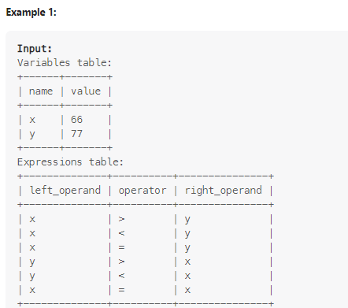
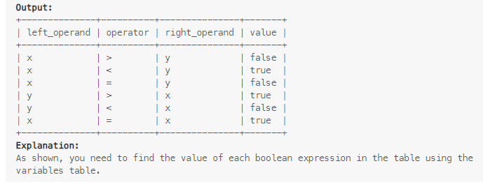
with cte as (select *, (case when operator=">" then (select value from variables where name=left_operand)>(select value from variables where name=right_operand)
when operator="<" then (select value from variables where name=left_operand)<(select value from variables where name=right_operand)
else (select value from variables where name=left_operand)=(select value from variables where name=right_operand)end)
as k from expressions)
select left_operand, operator,right_operand,(case when k=0 then "false" else "true" end ) as value from cte ;

41. The median is the value separating the higher half from the lower half of a data sample. Write an SQL query to report the median of all the numbers in the database after decompressing the Numbers table. Round the median to one decimal point. The query result format is in the following example.
This question was asked in a Pinterest company interview.

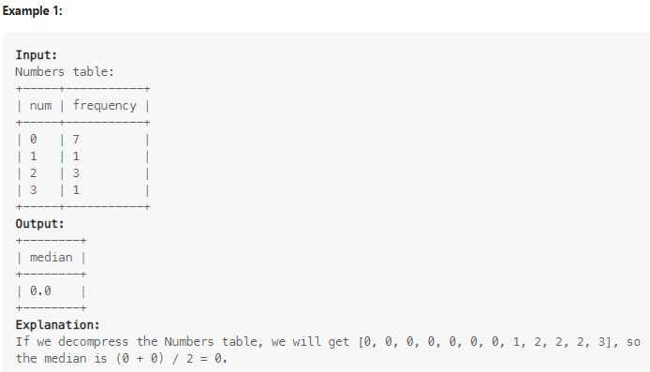
with cte as (select *,sum(frequency) over (order by num) as s from numbers),
c as (select *,lag(s,1,0) over (order by num) as t from cte),
d as (select t,s,num from c),
e as (select s from d order by s desc limit 1)
select round((case when (select s from e) %2=0 then (select avg(num) from d where (floor((select s from e)/2)>t and floor((select s from e)/2)<=s ) or (floor((select s from e)/2)+1>t and floor((select s from e)/2)+1<=s))
when (select s from e) %2<>0 then (select (num) from d where ((select s from e)+1)/2 >t and ((select s from e)+1)/2<=s)
end
),1)as k from d limit 1;

42. Write an SQL query to display the records with three or more rows with consecutive id's, and the number of people is greater than or equal to 100 for each. Return the result table ordered by visit_date in ascending order. The query result format is in the following example.

This question was asked in an Amazon company interview.
WITH Consecutive AS (
SELECT
id,
visit_date,
people,
id - ROW_NUMBER() OVER (ORDER BY id) AS grp
FROM Stadium
WHERE people >= 100
)
SELECT
id,
visit_date,
people
FROM Consecutive
WHERE grp IN (
SELECT grp
FROM Consecutive
GROUP BY grp
HAVING COUNT(*) >= 3
)
ORDER BY visit_date;
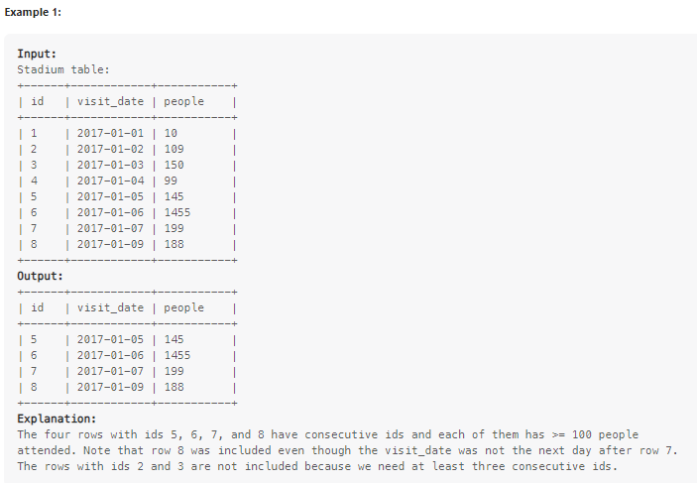

43. Write an SQL query to report the comparison result (higher/lower/same) of the average salary of employees in a department to the company's average salary. Return the result table in any order. The query result format is in the following example.
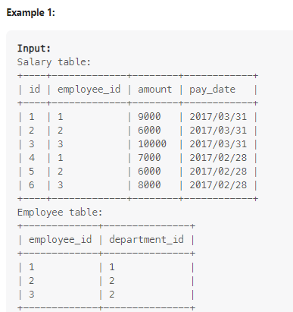
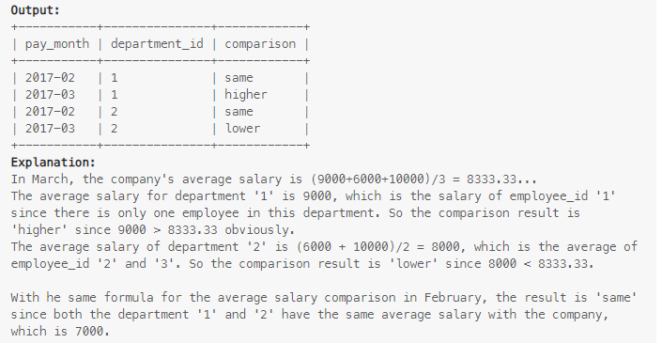

with cte as (select date_format(pay_date,"%Y-%m") as datee,avg(amount) as co_sal from employee join salary where employee.employee_id=salary.employee_id group by date_format(pay_date,"%Y-%m")),
c as (select department_id,avg(amount) as amt ,date_format(pay_date,"%Y-%m") as datee from employee as emp join salary as s on s.employee_id=emp.employee_id group by department_id,date_format(pay_date,"%Y-%m"))
select c.datee as pay_month,department_id,(case when co_sal>amt then 'lower' when co_sal<amt then 'higher' else 'same' end) as comparison from cte join c on cte.datee=c.datee order by department_id ;

44. A school has students from Asia, Europe, and America. Write an SQL query to pivot the continent column in the Student table so that each name is sorted alphabetically and displayed underneath its corresponding continent. The output headers should be America, Asia, and Europe, respectively. The test cases are generated so that the student number from America is not less than either Asia or Europe. The query result format is in the following example.

This question was asked in an Amazon company interview.

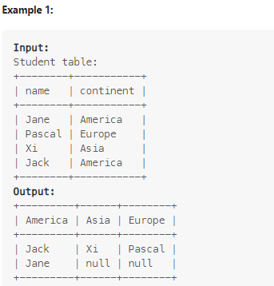

with cte as (select *,row_number() over (partition by continent order by name) as r from student),
d as (select * from cte where continent='America') ,
e as (select * from cte where continent='Asia') ,
f as (select * from cte where continent='Europe')
select d.name as America,e.name as Asia,f.name as Europe from d left join e on d.r=e.r left join f on f.r=d.r;

45. Write an SQL query to report the total sales amount of each item for each year, with corresponding product_name, product_id, report_year, and total_amount. Return the result table ordered by product_id and report_year. The query result format is in the following example.

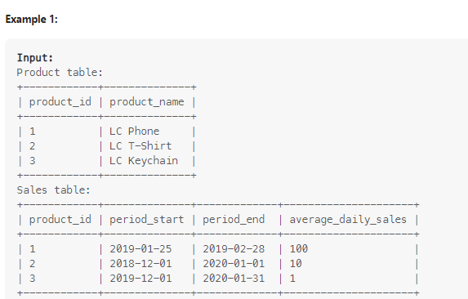

WITH RECURSIVE years AS (
-- Generate all years that appear in the sales data
SELECT DISTINCT YEAR(period_start) AS report_year
FROM Sales
UNION
SELECT DISTINCT YEAR(period_end) AS report_year
FROM Sales
),
sales_by_year AS (
SELECT
s.product_id,
y.report_year,
s.average_daily_sales,
-- Calculate the start date for this year
CASE
WHEN YEAR(s.period_start) = y.report_year
THEN s.period_start
ELSE DATE(CONCAT(y.report_year, '-01-01'))
END AS year_start,
-- Calculate the end date for this year
CASE
WHEN YEAR(s.period_end) = y.report_year
THEN s.period_end
ELSE DATE(CONCAT(y.report_year, '-12-31'))
END AS year_end
FROM Sales s
JOIN years y
ON y.report_year BETWEEN YEAR(s.period_start) AND YEAR(s.period_end)
)
SELECT
p.product_id,
p.product_name,
sby.report_year,
ROUND(sby.average_daily_sales * (DATEDIFF(sby.year_end, sby.year_start) + 1), 0) AS total_amount
FROM sales_by_year sby
JOIN Product p ON sby.product_id = p.product_id
ORDER BY p.product_id, sby.report_year;
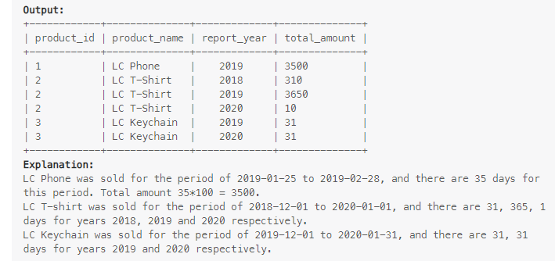

46. Write an SQL query to report the percentage of working drivers (working_percentage) for each month of 2020 where:
Note that if the number of available drivers during a month is zero, we consider the working_percentage to be 0. Return the result table ordered by month in ascending order, where month is the month's number (January is 1, February is 2, etc.). Round working_percentage to the nearest 2 decimal places. The query result format is in the following example.
This question was asked in an Uber company interview.
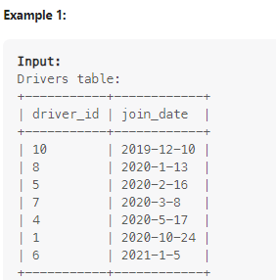
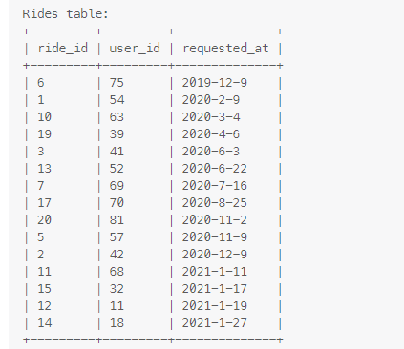
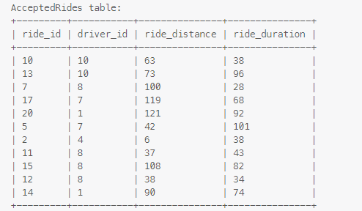
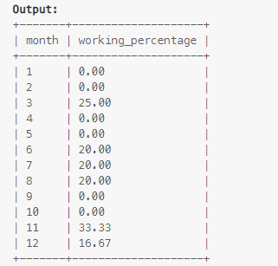
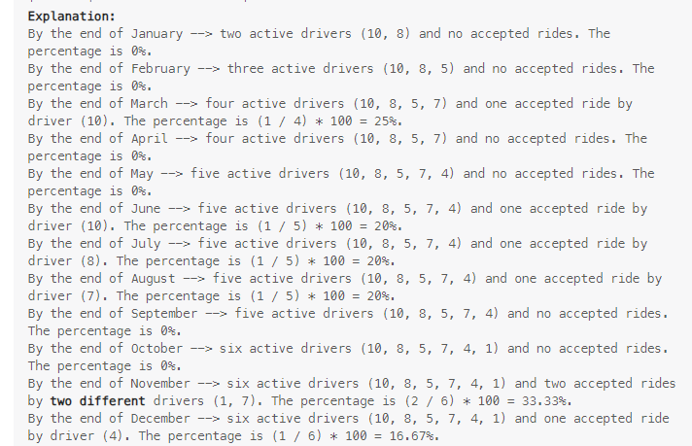
WITH months AS (
SELECT 1 AS month UNION SELECT 2 UNION SELECT 3 UNION SELECT 4
UNION SELECT 5 UNION SELECT 6 UNION SELECT 7 UNION SELECT 8
UNION SELECT 9 UNION SELECT 10 UNION SELECT 11 UNION SELECT 12
),
available AS (
SELECT
m.month,
COUNT(d.driver_id) AS available_drivers
FROM months m
LEFT JOIN Drivers d
ON d.join_date <= DATE(CONCAT('2020-', LPAD(m.month, 2, '0'), '-01'))
GROUP BY m.month
),
working AS (
SELECT
MONTH(r.requested_at) AS month,
COUNT(DISTINCT ar.driver_id) AS working_drivers
FROM Rides r
JOIN AcceptedRides ar ON r.ride_id = ar.ride_id
WHERE YEAR(r.requested_at) = 2020
GROUP BY MONTH(r.requested_at)
)
SELECT
a.month,
ROUND(
CASE
WHEN a.available_drivers = 0 THEN 0
ELSE (w.working_drivers / a.available_drivers) * 100
END,
2) AS working_percentage
FROM available a
LEFT JOIN working w ON a.month = w.month
ORDER BY a.month;

47. Write an SQL query to report the IDs of the missing subtasks for each task_id. Return the result table in any order. The query result format is in the following example.
This question was asked in a Google company interview.
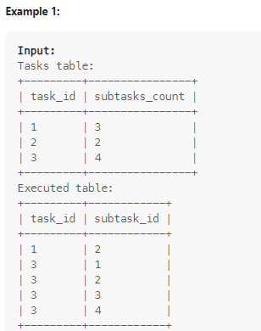
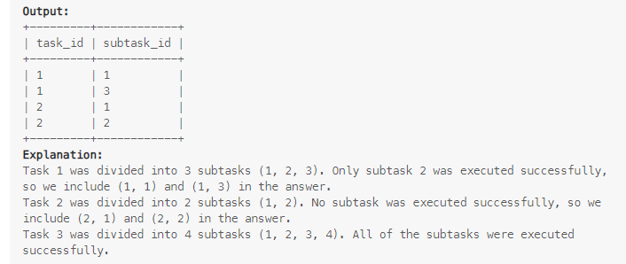
WITH RECURSIVE nums AS (
SELECT 1 AS n
UNION ALL
SELECT n + 1 FROM nums WHERE n + 1 <= (SELECT MAX(subtasks_count) FROM Tasks)
)
SELECT
t.task_id,
nums.n AS missing_subtask_id
FROM Tasks t
JOIN nums ON nums.n <= t.subtasks_count
LEFT JOIN Executed e
ON e.task_id = t.task_id AND e.subtask_id = nums.n
WHERE e.subtask_id IS NULL;

48. The winner in each group is the player who scored the maximum total points within the group. In the case of a tie, the lowest player_id wins. Write an SQL query to find the winner in each group. Return the result table in any order. The query result format is in the following example.
This question was asked in a Wayfair company interview.

with cte as (select match_id,(case when first_score<second_score then second_player when first_score>second_score then first_player else least(first_player,second_player) end ) as d from matches),
c as (select * from cte join players on players.player_id=cte.d)
select group_id,min(player_id) as player_id fr

om c group by group_id order by group_id;
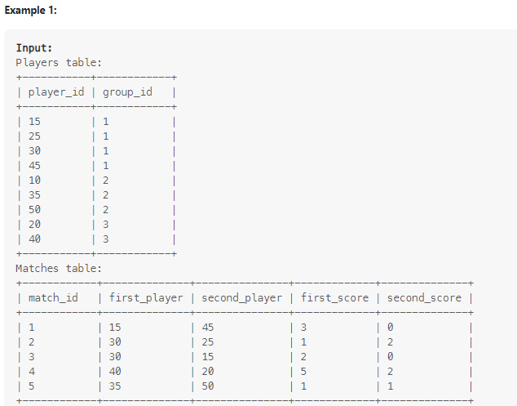
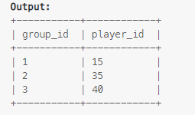

49. Write an SQL query to show the second most recent activity of each user. If the user only has one activity, return that one. A user cannot perform more than one activity at the same time. Return the result table in any order. The query result format is in the following example.
This question was asked in a Microsoft company interview.
with cte as (select * ,row_number() over(partition by username order by startdate) as r from useractivity ),
c as (select username from useractivity group by username having count(username)=1)
select username,activity,startdate,enddate from cte where r=2
union all
select * from useractivity where username in (select username from c );
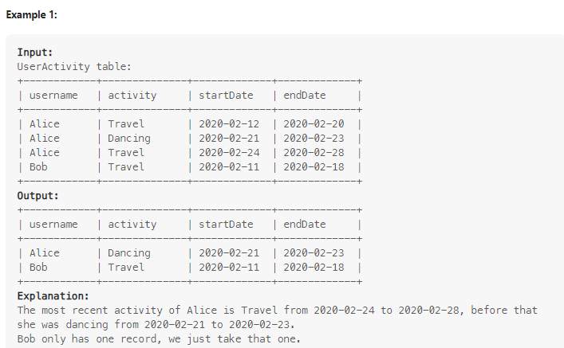

50. The install date of a player is the first login day of that player. We define day one retention of some date x to be the number of players whose install date is x and they logged back in on the day right after x, divided by the number of players whose install date is x, rounded to 2 decimal places. Write an SQL query to report for each install date, the number of players that installed the game on that day, and the day one retention. Return the result table in any order. The query result format is in the following example.
This question was asked in a GSN Games company interview.

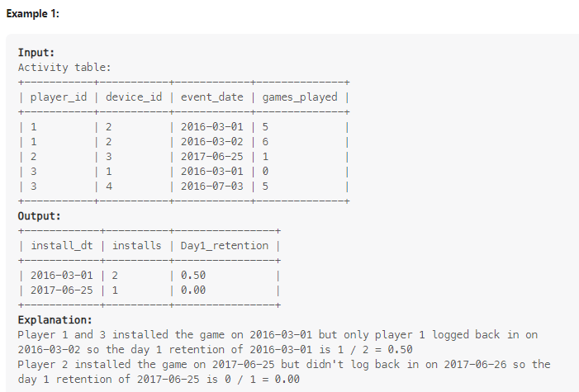

with cte as (select *, row_number() over(partition by event_date order by event_date) from activity ),
c as (select *, datediff(lead(event_date,1,event_date) over (partition by player_id order by event_date),event_date) as dif from cte),
d as (select event_date,dif from c ),
e as (select event_date,count(*) as installs from c group by event_date )
select e.event_date as install_dt, installs ,round(dif/installs,2) as day1_retention from d join e on d.event_date=e.event_date where dif=1 or dif=0;

